**PHASE 3 SUBMISSION DOCUMENT**

**Project:** E-COMMERCE APPLICATION USING CLOUD COMPUTING

**Introduction**

Creating a simple e-commerce application using HTML, CSS, and Flask involves setting up a basic web application that can display product listings and allow users to add products to a shopping cart. Here's a simplified example to get you started:

**Create HTML Templates:**

In your project directory, create HTML templates for different pages of your e-commerce website. For example:

“templates/index.html”for the homepage.

“templates/products.html” to display product listings.

“templates/cart.html” to show the shopping cart.

**Develop the Front-End:**

Build the front-end of your e-commerce website using HTML and CSS. You can also use a front-end framework like Bootstrap or Bulma for styling. Customize these templates to suit your needs, including product details, images, and prices.

**Index.html**

<!doctype html>

<html class="no-js" lang="en">

  <head>

    <meta charset="utf-8" />

    <meta name="viewport" content="width=device-width, initial-scale=1.0" />

    <title>Modern Artisanals</title>

    <link rel="stylesheet" href="css/foundation.css" />

    <script src="js/vendor/modernizr.js"></script>

  </head>

  <body>

    <nav class="top-bar" data-topbar role="navigation">

      <ul class="title-area">

        <li class="name">

          <h1><a href="index.php">Modern Artisanal Shop</a></h1>

        </li>

        <li class="toggle-topbar menu-icon"><a href="#"><span></span></a></li>

      </ul>

      <section class="top-bar-section">

      <!-- Right Nav Section -->

        <ul class="right">

          <li><a href="about.php">About</a></li>

          <li><a href="products.php">Products</a></li>

          <li><a href="cart.php">View Cart</a></li>

          <li><a href="orders.php">My Orders</a></li>

          <li><a href="contact.php">Contact</a></li>

          <?php

          if(isset($_SESSION['username'])){

            echo '<li><a href="account.php">My Account</a></li>';

            echo '<li><a href="logout.php">Log Out</a></li>';

          }

          else{

            echo '<li><a href="login.php">Log In</a></li>';

            echo '<li><a href="register.php">Register</a></li>';

          }

          ?>

        </ul>

      </section>

    </nav>

    <img style="width:100%"; data-interchange="[images/bolt-retina.jpg, (retina)], [images/bolt-landscape.jpg, (large)], [images/bolt-mobile.jpg, (mobile)], [images/bolt-landscape.jpg, (medium)]">

    <noscript><img src="images/bolt-mobile.jpg" ></noscript>

    <div class="row" style="margin-top:10px;">

      <div class="small-12">

        <footer style="margin-top:10px;">

           <p style="text-align:center; font-size:0.8em;">&copy; Modern Artisanal Shop. All Rights Reserved.</p>

        </footer>

      </div>

    </div>

**Output:** 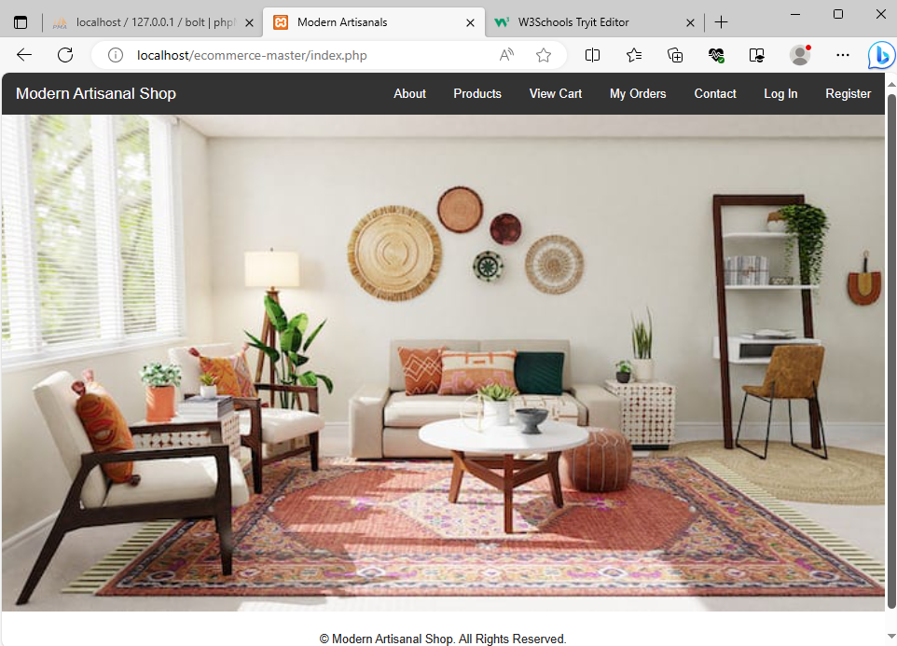

**Database to store products:**

To create a product details in website:

CREATE TABLE IF NOT EXISTS `products` (

  `id` int(11) NOT NULL auto_increment,

  `product_code` varchar(60) NOT NULL,

  `product_name` varchar(60) NOT NULL,

  `product_desc` tinytext NOT NULL,

  `product_img_name` varchar(60) NOT NULL,

  `qty` int(5) NOT NULL,

  `price` decimal(10,2) NOT NULL,

  PRIMARY KEY  (`id`),

  UNIQUE KEY `product_code` (`product_code`)) ENGINE=InnoDB  DEFAULT CHARSET=latin1 AUTO_INCREMENT=4 ;

Insert the table data:

INSERT INTO `products` (`id`, `product_code`, `product_name`, `product_desc`, `product_img_name`, `qty`, `price`) VALUES

(1, 'BOLT1', 'Sports Shoes', 'With a clean vamp, tonal stitch details throughout, and a unique formstripe finish, the all new sports shoes fits the needs of multiple running consumers by offering an athletic and a lifestyle look.', 'sports_shoes.jpg', 26, 5000.00),

(2, 'BOLT2', 'Cap', 'A sleek, tonal stitched cap for runners. The plain texture and unique design will help runners to concentrate more on running and less on their hair. The combbination of casual and formal look is just brilliant.', 'cap.jpg', 7, 200.00),

(3, 'BOLT3', 'Sports Band', 'The Sports Band collection features highly polished stainless steel and space black stainless steel cases. The display is protected by sapphire crystal. And there is a choice of three different leather bands.', 'sports_band.jpg', 34, 1000.00);

**Conclusion:**

These are basic HTML templates, and you can enhance them with CSS for styling and add JavaScript for interactivity. Additionally, for a complete e-commerce application, you would integrate these templates with a Flask backend to handle user interactions, product data, and the shopping cart functionality.